WEDDING PLANNER

|  |  |  |
| --- | --- | --- |
| supervisor | Miss muniba | |
| Batch | 2110f1 | |
| group | A | |
| Serial no | enrollment | Student name |
| 1 | 1340184 | Asher |
| 2 | 1339931 | Ali |
| 3 | 1340161 | Zoya |
| 4 | 1338679 | Junaid |

WEDDING PLANNER

1. **Home**(index.html)

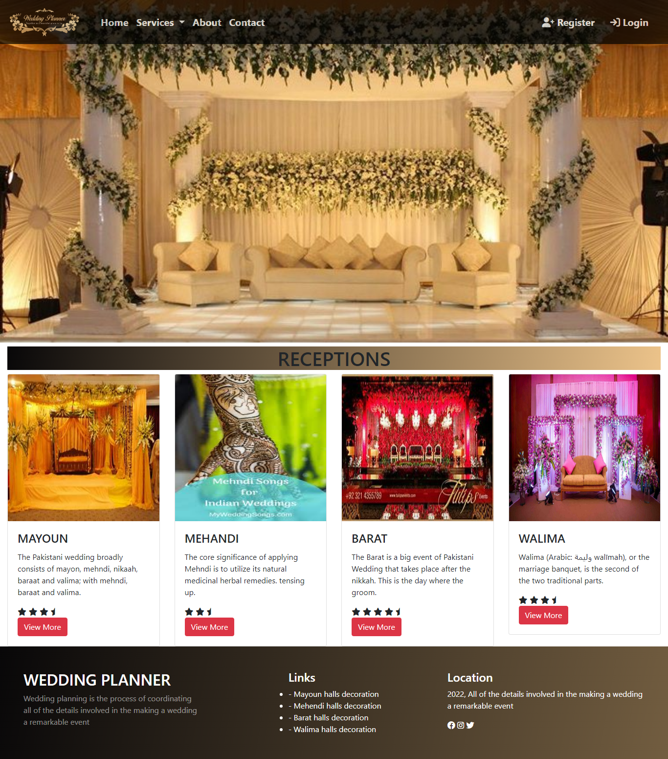

**Figure 1: Home page of wedding planner**

1. **Navbar**(index.html)



**Figure 2: Navbar**

We have given six essentials.by clicking any of the essentials and redirect to the linked page. (index.html)

**About us**(index.html)

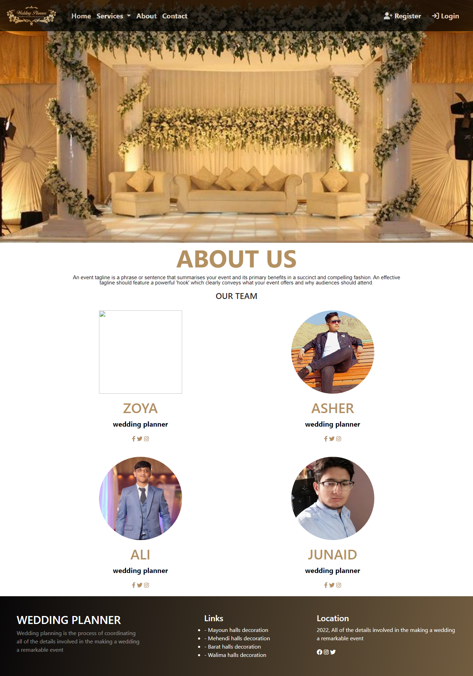

**Figure 3: About us**

* A wedding planner is a professional we assist with the design planning andmanagement of a client's wedding.
* Weddings are significant events in people's lives and as such, couples are often willing to spend considerable amount of money to ensure that their weddings are well-organized.

**Our Team**

**It’s are team we work together to make our website awesome now I will tell you about our team member.**

1. **Asher Ahmad: Our group leader**
2. **Ali Mouhammed: Team member**
3. **Zoya: Team member**
4. **Junaid: Team member**

**Service(index.html)**

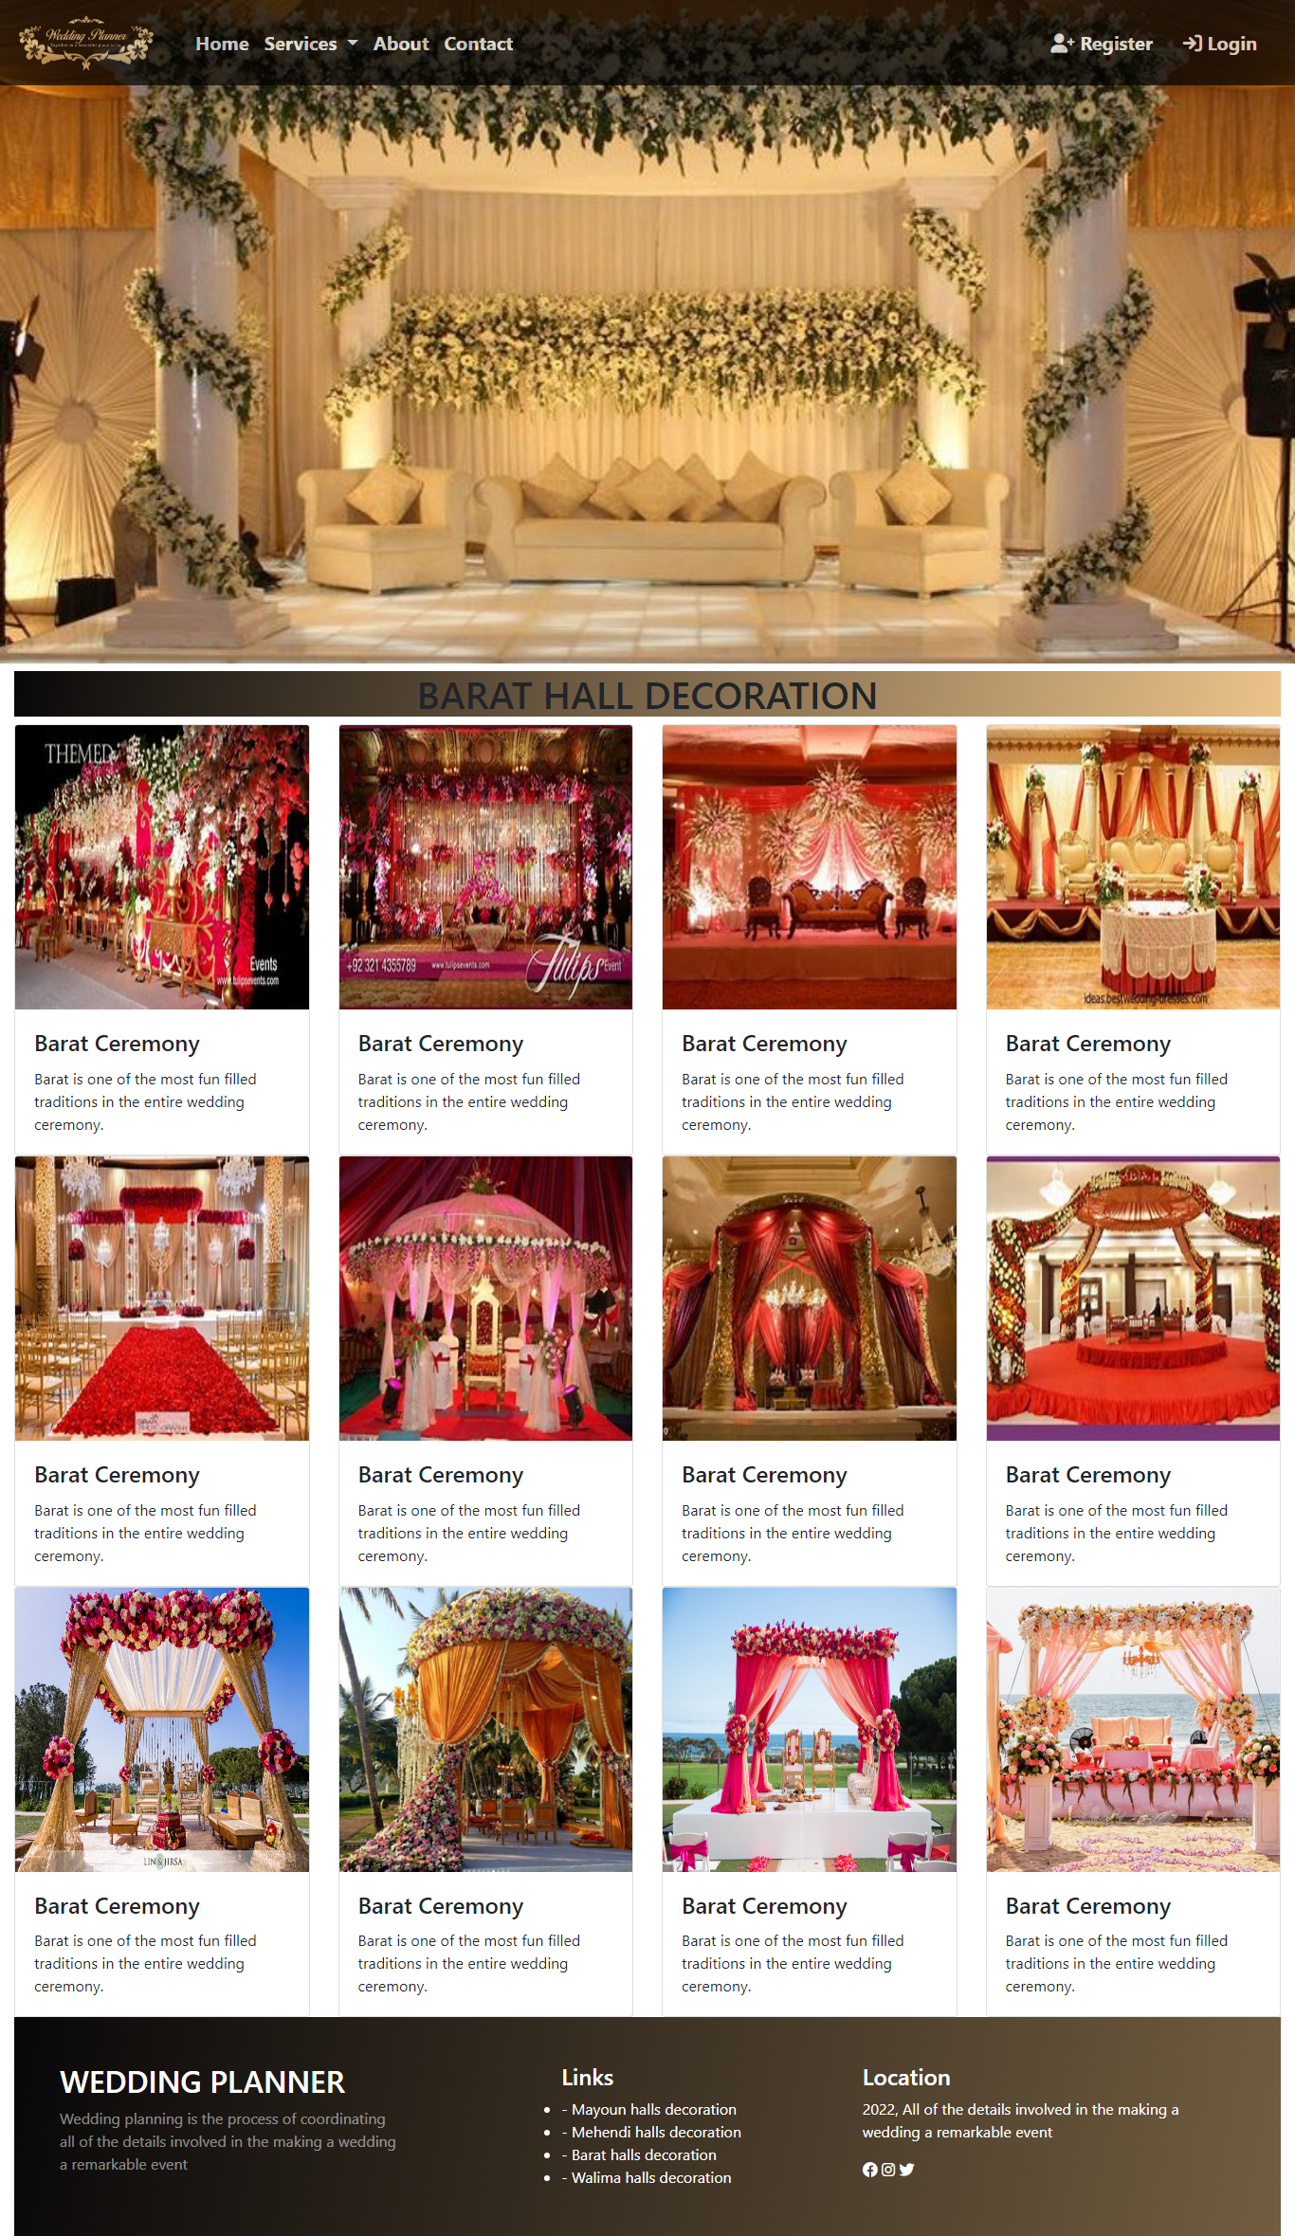

**Figure 4: BARAT**

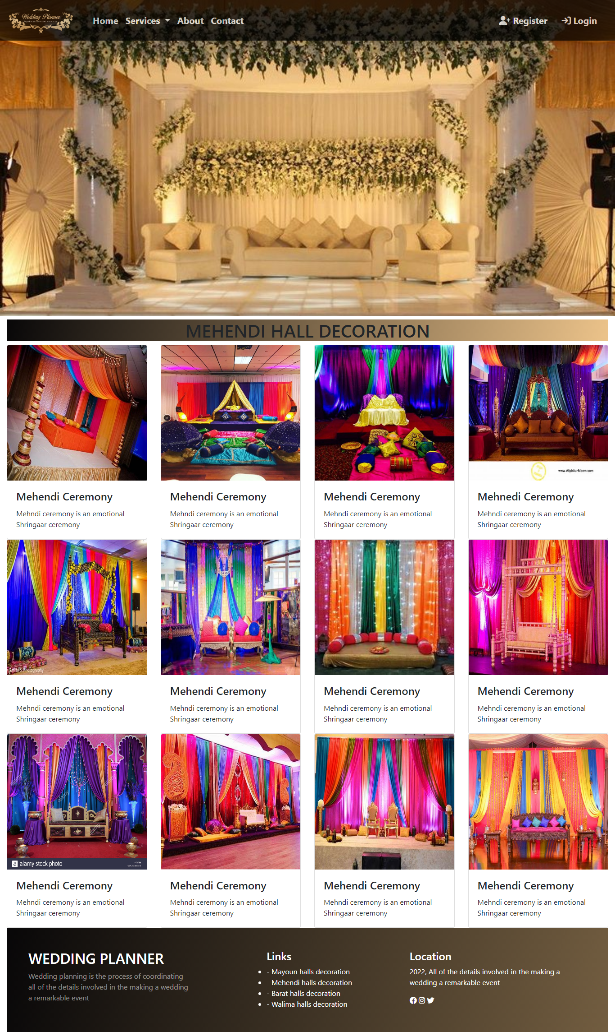

**Figure 5: mehndi**

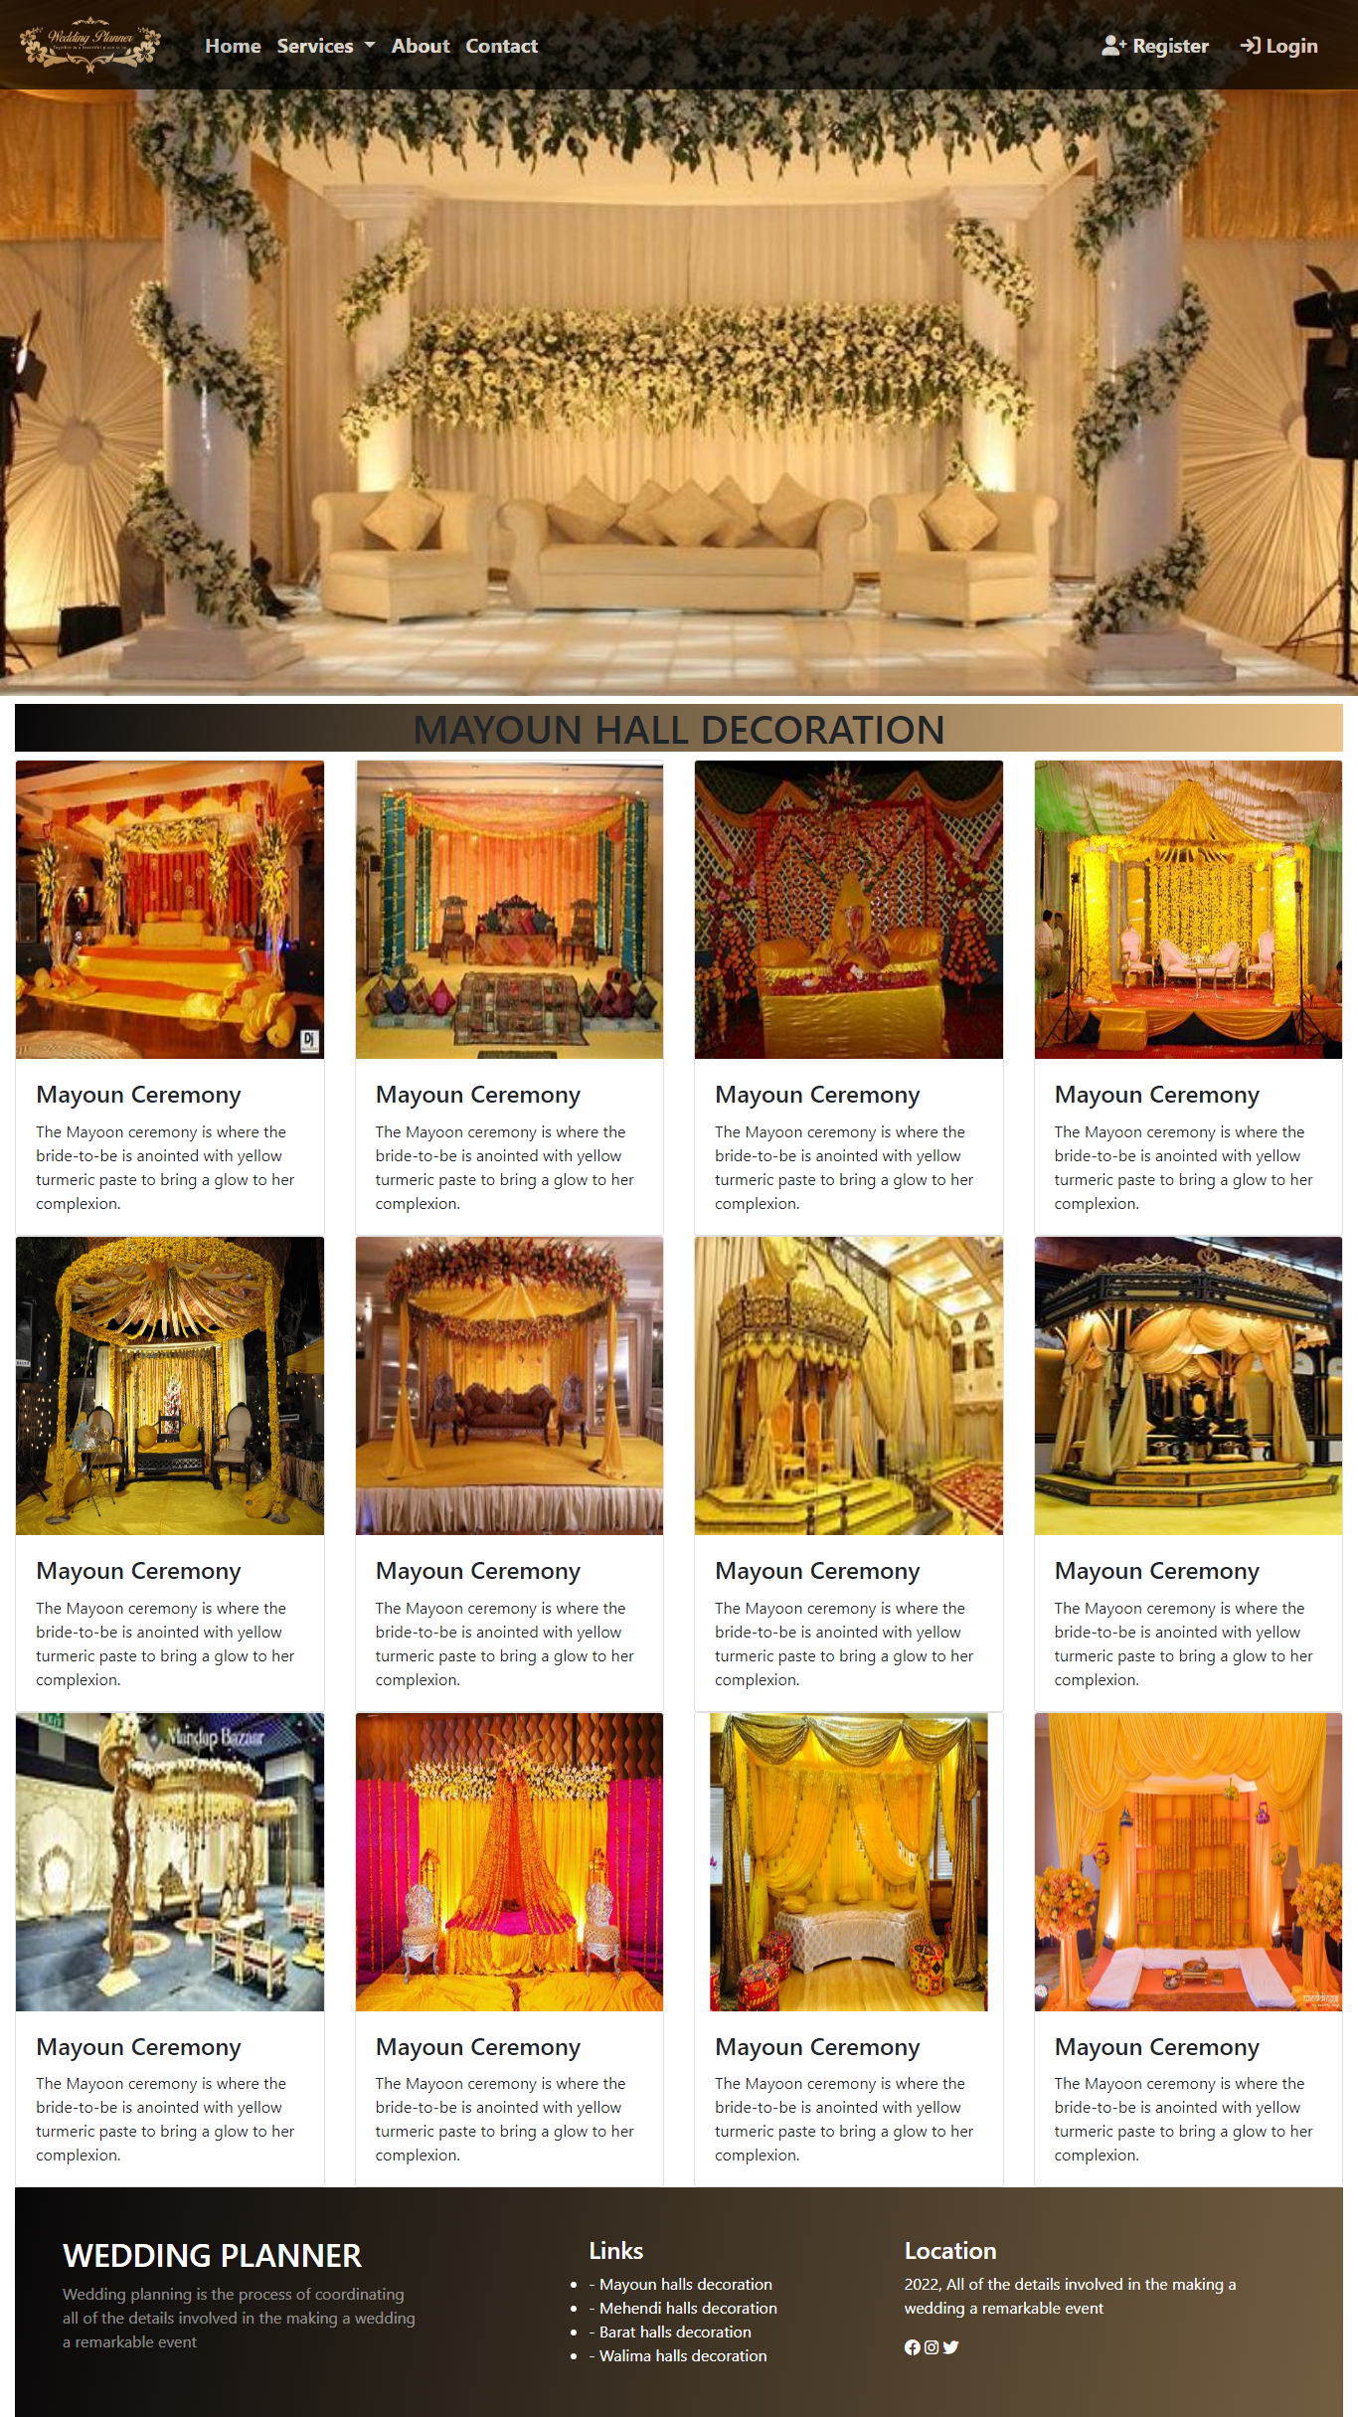

**Figure 6: mayoun**

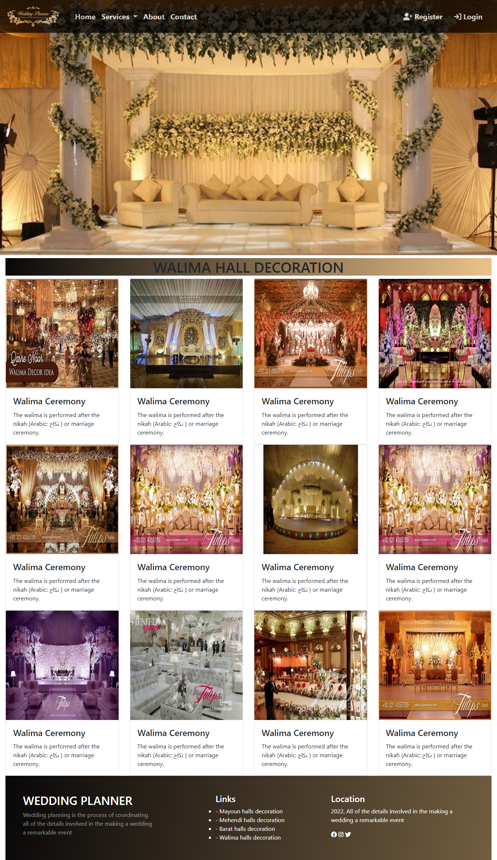

**Figure 7: walima**

We have mentioned our basic services to make people known about the services we provide.

1. Barat
2. Mehndi
3. Mayoun
4. Walima

**Contact(index.html)**

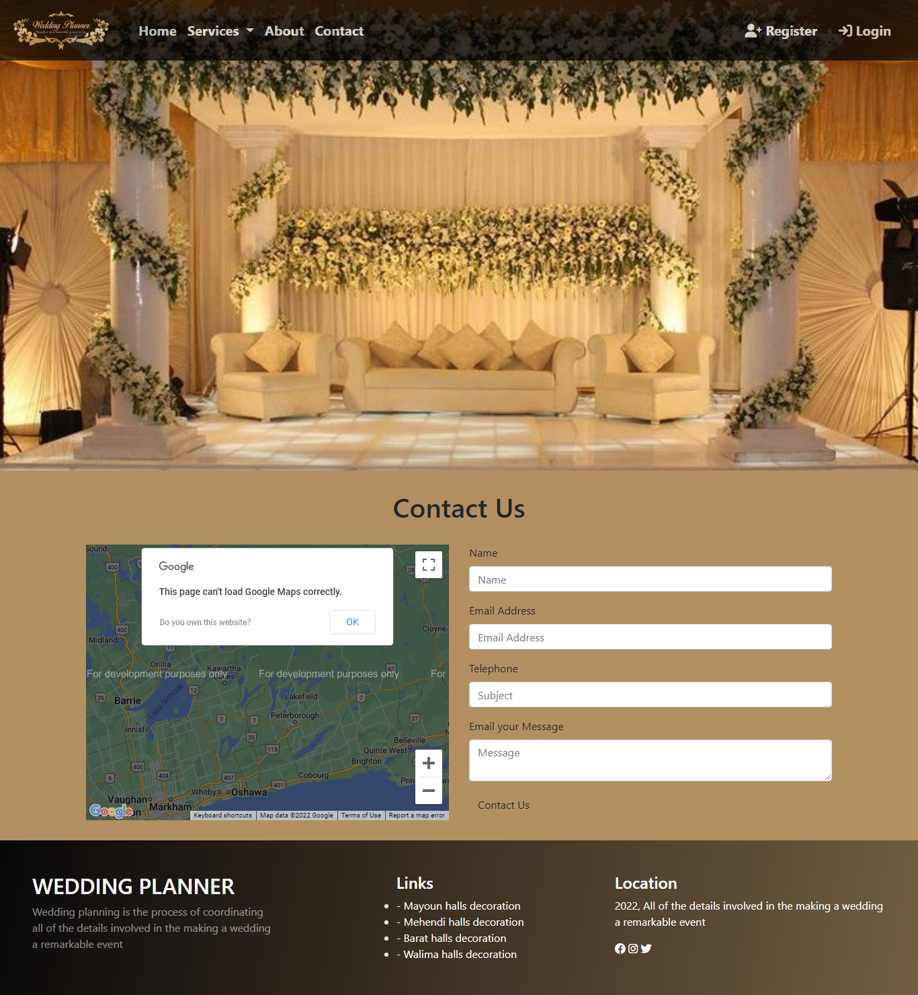

**Figure 8: contact**

In our contact section we have give location map for the ease of the people email id and phone number for contacting in case for any problem

**Contact form:**

To now the responsive of the people our team has given contact pagefor the ideas and feedback of the people

**Register(index.html)**

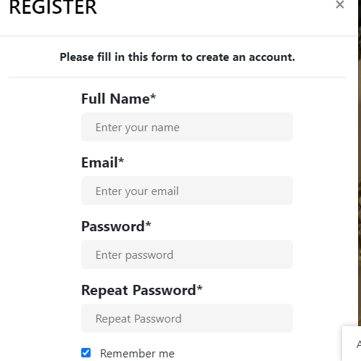

**Figure 9: Register form**

We have provided the registration form to our user in which the user registers their info for the wedding planner

**Login form(index.html)**

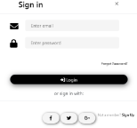

**Figure 10: login form**

A Login form is used to enter authentication credentials to access a restricted page or form. The login form contains a field for the username and another for the password.

**Footer(index.html)**

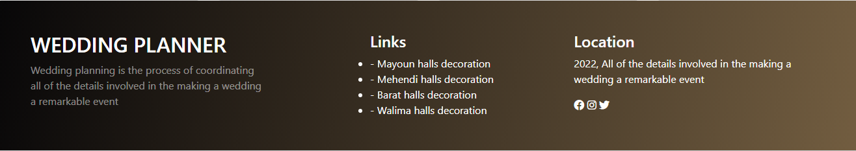

**Figure 9: Footer**

A footer is text such as a name or page number that can be automatically displayed at the bottom of each page of a printed document